**Frozen Locker**

**Offline Password Manager**

Offline Password Manager is an App that will help you to maintain your password for different accounts. It retrieves information about your account and stores the information in encrypted form in the database.Each Account data contains mainly three information, details about the account like which or what account it is eg(Gmail, Amazon account, etc).Username of the account and the password. The information is encrypted using (AES) algorithm using a master key.

The application mainly contains two activities.

* MainActivity
* About Activity

Two fragments

* Display_all fragment
* Add_up_fragment

**Main Activity**

The main components of this activity will be a TextBox, 2 Button and a FrameLayout for fragment Navigation. The textbox is used to retrieve the master key and upon clicking the retrieve button the Display_all fragment will be loaded.

**Display_all fragment**

The display fragment will retrieve all the account information from the database, decrypt the data using the master key and display the details in a Recycler view.The password of an account can be copied into the clipboard by long-pressing the corresponding item in the Recycler view.By clicking on a particular item in the recycler view, a dialog box will pop up showing the account details and two options either to update the account details or to delete the account details.The account details will be deleted by pressing the delete button. If the update button is pressed the control will be passed to the add_up fragment. The data about the account will be prefilled in the add_up fragment.

**Add/Update Fragment**

This Fragment is used to either add new Account details or update an existing one. If the Fragment is invoked for updating an account details the old details will be automatically populated in the corresponding Widgets.

**About Activity**

The About Activity shows some information about the Frozen Locker App.

**Options Menu**

An Options Menu to navigate between main activity and about activity

**Main Functionalities**

* Add Account Details
* update Account Details
* Delete Account Details
* Retrieve Account Details

**Add Account Details**

Add information about a new account(username, password, which account it is) into the database.

**Update Account Details**

Update the information about an account that is already stored in the database.

**Delete Account Details**

Delete the details about an account stored in the database.

**Retrieve Account Details**

Retrieve all the Account information, decrypt the information and display the details

Offline Password Manager Structure

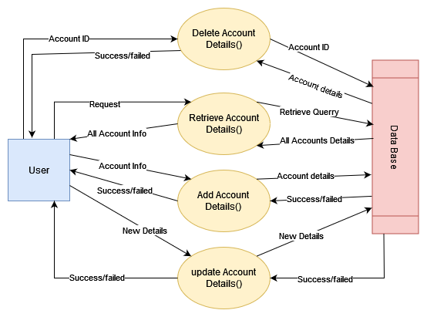

Main Android Components

* Activity​
* Activity Navigation (Intent) ​
* Fragment​
* Fragment Navigation ​
* Recycler View​
* Option Menu​
* Dialog Box​
* Image Button​
* implicit intent​
* Basic Form elements
* Database​
  + Insertion ​
  + Updation
  + Deletion

Code

Activity 1 main Activity

**MainActivity.java**

package com.example.projectfrozenlocker20;

import androidx.annotation.NonNull;

import androidx.appcompat.app.AppCompatActivity;

import androidx.fragment.app.Fragment;

import androidx.fragment.app.FragmentManager;

import androidx.fragment.app.FragmentTransaction;

import android.content.Intent;

import android.os.Bundle;

import android.util.Log;

import android.view.Menu;

import android.view.MenuInflater;

import android.view.MenuItem;

import android.view.View;

import android.widget.EditText;

import android.widget.Toast;

public class MainActivity extends AppCompatActivity {

Locker lk;

DBmanager dbm;

@Override

protected void onCreate(Bundle savedInstanceState) {

super.onCreate(savedInstanceState);

setContentView(R.layout.*activity_main*);

Log.*i*("errorsolve", "in main");

dbm = new DBmanager(this);

lk = new Locker();

}

public void retrive_all_accounts(View view) {

String ky = ((EditText) findViewById(R.id.*etxt_pass*)).getText().toString();

Locker.*setKey*(ky);

Log.*i*("errorsolve", "in retrive all account");

replaceFargment(new Display_accounts_Fragment(this));

}

public void replaceFargment(Fragment far){

Log.*i*("errorsolve", "in replaceFargment");

FragmentManager fragmentManager = getSupportFragmentManager();

FragmentTransaction fragmentTransaction = fragmentManager.beginTransaction();

fragmentTransaction.replace(R.id.*frm1*, far);

fragmentTransaction.commit();

Log.*i*("errorsolve", "in replaceFargment end");

}

public void addNewAccount(View view) {

replaceFargment(new Add_up_fragment("add", this));

}

@Override

public boolean onCreateOptionsMenu(Menu menu) {

MenuInflater in = getMenuInflater();

in.inflate(R.menu.*option_menu*, menu);

return true;

}

@Override

public boolean onOptionsItemSelected(@NonNull MenuItem item) {

switch (item.getItemId()){

case R.id.*about_iteam*:

Intent intent = new Intent(this, About.class);

startActivity(intent);

Toast.*makeText*(this, "About iteam selected", Toast.*LENGTH_LONG*).show();

return true;

case R.id.*iteam2*:

Toast.*makeText*(this, "Iteam2 selected", Toast.*LENGTH_LONG*).show();

return true;

case R.id.*iteam3*:

Toast.*makeText*(this, "Iteam3 selected", Toast.*LENGTH_LONG*).show();

return true;

default:

return super.onOptionsItemSelected(item);

}

}

}

**activity_main.xml**

**<?xml version="1.0" encoding="utf-8"?>**

**<androidx.constraintlayout.widget.ConstraintLayout xmlns:android="http://schemas.android.com/apk/res/android"**

**xmlns:app="http://schemas.android.com/apk/res-auto"**

**xmlns:tools="http://schemas.android.com/tools"**

**android:layout_width="match_parent"**

**android:layout_height="match_parent"**

**android:background="#EDECDA"**

**tools:context=".MainActivity">**

**<EditText**

**android:id="@+id/etxt_pass"**

**android:layout_width="wrap_content"**

**android:layout_height="wrap_content"**

**android:layout_marginStart="4dp"**

**android:layout_marginLeft="4dp"**

**android:layout_marginTop="16dp"**

**android:ems="10"**

**android:inputType="textPassword"**

**android:textColor="#0C0C0C"**

**app:layout_constraintEnd_toStartOf="@+id/btn_retrive"**

**app:layout_constraintHorizontal_bias="0.0"**

**app:layout_constraintStart_toStartOf="parent"**

**app:layout_constraintTop_toTopOf="parent" />**

**<Button**

**android:id="@+id/btn_retrive"**

**android:layout_width="wrap_content"**

**android:layout_height="wrap_content"**

**android:layout_marginTop="16dp"**

**android:layout_marginEnd="16dp"**

**android:layout_marginRight="16dp"**

**android:onClick="retrive_all_accounts"**

**android:text="Retrive"**

**app:layout_constraintEnd_toStartOf="@+id/add_btn"**

**app:layout_constraintTop_toTopOf="parent" />**

**<FrameLayout**

**android:id="@+id/frm1"**

**android:layout_width="match_parent"**

**android:layout_height="600sp"**

**android:layout_marginTop="12dp"**

**app:layout_constraintTop_toBottomOf="@+id/etxt_pass"**

**tools:layout_editor_absoluteX="-41dp">**

**</FrameLayout>**

**<com.google.android.material.floatingactionbutton.FloatingActionButton**

**android:id="@+id/add_btn"**

**android:layout_width="wrap_content"**

**android:layout_height="504dp"**

**android:layout_marginTop="8dp"**

**android:layout_marginEnd="16dp"**

**android:layout_marginRight="16dp"**

**android:clickable="true"**

**android:onClick="addNewAccount"**

**app:layout_constraintEnd_toEndOf="parent"**

**app:layout_constraintTop_toTopOf="parent"**

**app:srcCompat="@android:drawable/ic_menu_add" />**

**</androidx.constraintlayout.widget.ConstraintLayout>**

**Activity 2 = About**

**About.java**

**package com.example.projectfrozenlocker20;**

**import androidx.appcompat.app.AppCompatActivity;**

**import android.content.Intent;**

**import android.net.Uri;**

**import android.os.Bundle;**

**import android.view.View;**

**public class About extends AppCompatActivity {**

**@Override**

**protected void onCreate(Bundle savedInstanceState) {**

**super.onCreate(savedInstanceState);**

**setContentView(R.layout.activity_about);**

**}**

**public void goToSite(View view) {**

**Intent browserIntent = new Intent(Intent.ACTION_VIEW,**

**Uri.parse("https://developer.android.com/"));**

**startActivity(browserIntent);**

**}**

**}**

**activity_about.xml**

**<?xml version="1.0" encoding="utf-8"?>**

**<androidx.constraintlayout.widget.ConstraintLayout xmlns:android="http://schemas.android.com/apk/res/android"**

**xmlns:app="http://schemas.android.com/apk/res-auto"**

**xmlns:tools="http://schemas.android.com/tools"**

**android:layout_width="match_parent"**

**android:layout_height="match_parent"**

**tools:context=".About">**

**<TextView**

**android:id="@+id/textView"**

**android:layout_width="wrap_content"**

**android:layout_height="wrap_content"**

**android:textSize="20sp"**

**android:layout_marginStart="35dp"**

**android:layout_marginLeft="35dp"**

**android:layout_marginTop="50dp"**

**android:text="About Frozen Locker"**

**app:layout_constraintStart_toStartOf="parent"**

**app:layout_constraintTop_toTopOf="parent" />**

**<TextView**

**android:id="@+id/about_txt2"**

**android:layout_width="360dp"**

**android:layout_height="95dp"**

**android:layout_marginStart="24dp"**

**android:layout_marginLeft="24dp"**

**android:layout_marginTop="12dp"**

**android:text="Offline Password Manager is an App that will help you to**

**maintain your password for different accounts.\nIt retrieves information about your account like\nusername, password, and which account it is.\nLater the information is stored in encrypted form in the**

**database. The information is encrypted using a Master key.**

**"**

**app:layout_constraintStart_toStartOf="parent"**

**app:layout_constraintTop_toBottomOf="@+id/textView" />**

**<TextView**

**android:id="@+id/about_txt3"**

**android:layout_width="wrap_content"**

**android:layout_height="wrap_content"**

**android:layout_marginStart="24dp"**

**android:layout_marginLeft="24dp"**

**android:layout_marginTop="40dp"**

**android:text="Click on the image to go to our web site"**

**android:textSize="20sp"**

**app:layout_constraintStart_toStartOf="parent"**

**app:layout_constraintTop_toBottomOf="@+id/about_txt2" />**

**<ImageButton**

**android:id="@+id/imageButton"**

**android:layout_width="wrap_content"**

**android:layout_height="wrap_content"**

**android:layout_marginStart="148dp"**

**android:layout_marginLeft="148dp"**

**android:layout_marginTop="68dp"**

**android:background="#70D868"**

**android:onClick="goToSite"**

**app:layout_constraintStart_toStartOf="parent"**

**app:layout_constraintTop_toBottomOf="@+id/about_txt3"**

**app:srcCompat="@drawable/ic_launcher_foreground"**

**tools:ignore="VectorDrawableCompat" />**

**</androidx.constraintlayout.widget.ConstraintLayout>**

**Fragment 1 = Display_accounts_Fragment**

**Display_accounts_Fragment.java**

package com.example.projectfrozenlocker20;

import android.app.Activity;

import android.os.Build;

import android.os.Bundle;

import androidx.annotation.RequiresApi;

import androidx.fragment.app.Fragment;

import androidx.fragment.app.FragmentManager;

import androidx.fragment.app.FragmentTransaction;

import androidx.recyclerview.widget.LinearLayoutManager;

import androidx.recyclerview.widget.RecyclerView;

import android.view.LayoutInflater;

import android.view.View;

import android.view.ViewGroup;

import java.util.ArrayList;

public class Display_accounts_Fragment extends Fragment {

View view;

private ArrayList<Account> list= new ArrayList<Account>();

public DBmanager db;

public Display_accounts_Fragment(Activity c) {

db = new DBmanager(c);

// Required empty public constructor

}

@Override

public void onCreate(Bundle savedInstanceState) {

super.onCreate(savedInstanceState);

}

@RequiresApi(api = Build.VERSION_CODES.*O*)

@Override

public View onCreateView(LayoutInflater inflater, ViewGroup container,

Bundle savedInstanceState) {

// Inflate the layout for this fragment

view = inflater.inflate(R.layout.*fragment_display_accounts_*, container, false);

buildListData();

initRecyclerView(view);

return view;

}

private void initRecyclerView(View view) {

RecyclerView recyclerView = view.findViewById(R.id.*recycleView*);

LinearLayoutManager linearLayoutManager = new LinearLayoutManager(getActivity());

recyclerView.setLayoutManager(linearLayoutManager);

Account_RcAdapter adapter = new Account_RcAdapter(getActivity(), list, getActivity().getSupportFragmentManager().beginTransaction());

recyclerView.setAdapter(adapter);

}

@RequiresApi(api = Build.VERSION_CODES.*O*)

private void buildListData() {

list = db.retriveAllAccounts();

}

}

**Fragment_display_accounts_.xml**

**<?xml version="1.0" encoding="utf-8"?>**

**<LinearLayout xmlns:android="http://schemas.android.com/apk/res/android"**

**xmlns:tools="http://schemas.android.com/tools"**

**android:layout_width="match_parent"**

**android:layout_height="match_parent"**

**tools:context=".Display_accounts_Fragment"**

**android:orientation="vertical">**

**<androidx.recyclerview.widget.RecyclerView**

**android:id="@+id/recycleView"**

**android:layout_width="match_parent"**

**android:layout_height="match_parent" />**

**</LinearLayout>**

**Fragment 2 = Add_up_fragment**

**Add_up_fragment.java**

**package com.example.projectfrozenlocker20;**

**import android.app.Activity;**

**import android.os.Build;**

**import android.os.Bundle;**

**import androidx.annotation.RequiresApi;**

**import androidx.fragment.app.Fragment;**

**import android.util.Log;**

**import android.view.LayoutInflater;**

**import android.view.View;**

**import android.view.ViewGroup;**

**import android.widget.Button;**

**import android.widget.EditText;**

**import android.widget.Toast;**

**public class Add_up_fragment extends Fragment {**

**//private static final String ARG_PARAM1 = "param1";**

**//private static final String ARG_PARAM2 = "param2";**

**// *TODO: Rename and change types of parameters***

**private String type;**

**private Account acc;**

**DBmanager db;**

**public Add_up_fragment() {**

**// Required empty public constructor**

**//db = new DBmanager(this);**

**}**

**public Add_up_fragment(String t, Account a, Activity c) {**

**type = t;**

**acc = a;**

**db = new DBmanager(c);**

**}**

**public Add_up_fragment(String t, Activity c) {**

**type = t;**

**db = new DBmanager(c);**

**}**

**@Override**

**public void onCreate(Bundle savedInstanceState) {**

**super.onCreate(savedInstanceState);**

**/\***

**if (getArguments() != null) {**

**mParam1 = getArguments().getString(ARG_PARAM1);**

**mParam2 = getArguments().getString(ARG_PARAM2);**

**}**

**\*/**

**}**

**@Override**

**public View onCreateView(LayoutInflater inflater, ViewGroup container,**

**Bundle savedInstanceState) {**

**// Inflate the layout for this fragment**

**View view = inflater.inflate(R.layout.*fragment_add_up_fragment*, container, false);**

**Button add_btn = (Button) view.findViewById(R.id.*btn_add*);**

**Button update_btn = (Button) view.findViewById(R.id.*btn_update*);**

**EditText what = (EditText) view.findViewById(R.id.*ad_etxt_waht*);**

**EditText username = (EditText) view.findViewById(R.id.*ad_etxt_username*);**

**EditText password = (EditText) view.findViewById(R.id.*ad_etxt_password*);**

**if(type == "update"){**

**what.setText(acc.what);**

**username.setText(acc.username);**

**password.setText(acc.password);**

**add_btn.setEnabled(false);**

**update_btn.setOnClickListener(new View.OnClickListener() {**

**@RequiresApi(api = Build.VERSION_CODES.*O*)**

**@Override**

**public void onClick(View v) {**

**Account updatedAccount = new Account(**

**acc.account_id,**

**what.getText().toString(),**

**username.getText().toString(),**

**password.getText().toString()**

**);**

**if(db.updateAccount(acc, updatedAccount)){**

**Toast.*makeText*(getActivity(),"Account Updated sucessfully",Toast.*LENGTH_LONG*).show();**

**}**

**else {**

**Toast.*makeText*(getActivity(),"Something went wrong",Toast.*LENGTH_LONG*).show();**

**}**

**Log.*i*("errorsolve", "added");**

**Log.*i*("errorsolve", "updated");**

**}**

**});**

**}**

**else if(type == "add"){**

**update_btn.setEnabled(false);**

**add_btn.setOnClickListener(new View.OnClickListener() {**

**@RequiresApi(api = Build.VERSION_CODES.*O*)**

**@Override**

**public void onClick(View v) {**

**Account a = new Account(**

**-1,**

**what.getText().toString(),**

**username.getText().toString(),**

**password.getText().toString()**

**);**

**if(db.addAccount(a)){**

**Toast.*makeText*(getActivity(),"Account Added sucessfully",Toast.*LENGTH_LONG*).show();**

**}**

**else {**

**Toast.*makeText*(getActivity(),"Something went wrong",Toast.*LENGTH_LONG*).show();**

**}**

**Log.*i*("errorsolve", "added");**

**}**

**});**

**}**

**return view;**

**}**

**}**

**Fragment_add_up_fragment.xml**

**<?xml version="1.0" encoding="utf-8"?>**

**<androidx.cardview.widget.CardView xmlns:android="http://schemas.android.com/apk/res/android"**

**xmlns:app="http://schemas.android.com/apk/res-auto"**

**xmlns:tools="http://schemas.android.com/tools"**

**android:id="@+id/add_up_far"**

**android:layout_width="match_parent"**

**android:layout_height="wrap_content"**

**app:cardCornerRadius="50dp"**

**tools:context=".Add_up_fragment">**

**<androidx.constraintlayout.widget.ConstraintLayout**

**android:layout_width="match_parent"**

**android:layout_height="wrap_content"**

**android:background="#69AAC8">**

**<TextView**

**android:id="@+id/ad_txt_what"**

**android:layout_width="wrap_content"**

**android:layout_height="wrap_content"**

**android:layout_marginLeft="30pt"**

**android:layout_marginTop="30pt"**

**android:text="What"**

**android:textColor="#050505"**

**android:textSize="20sp"**

**android:textStyle="bold"**

**app:layout_constraintStart_toStartOf="parent"**

**app:layout_constraintTop_toTopOf="parent" />**

**<EditText**

**android:id="@+id/ad_etxt_waht"**

**android:layout_width="wrap_content"**

**android:layout_height="wrap_content"**

**android:layout_marginLeft="30pt"**

**android:layout_marginTop="10sp"**

**android:hint="what"**

**android:minWidth="@android:dimen/thumbnail_width"**

**android:shadowColor="#9A0808"**

**android:textColor="#0B0A0A"**

**app:layout_constraintStart_toStartOf="parent"**

**app:layout_constraintTop_toBottomOf="@+id/ad_txt_what" />**

**<TextView**

**android:id="@+id/ad_txt_username"**

**android:layout_width="wrap_content"**

**android:layout_height="wrap_content"**

**android:layout_marginStart="30pt"**

**android:layout_marginLeft="30pt"**

**android:layout_marginTop="70dp"**

**android:text="Username"**

**android:textColor="#050505"**

**android:textSize="20sp"**

**android:textStyle="bold"**

**app:layout_constraintStart_toStartOf="parent"**

**app:layout_constraintTop_toTopOf="@+id/ad_etxt_waht" />**

**<EditText**

**android:id="@+id/ad_etxt_username"**

**android:layout_width="wrap_content"**

**android:layout_height="wrap_content"**

**android:layout_marginLeft="30pt"**

**android:layout_marginTop="10sp"**

**android:minWidth="@android:dimen/thumbnail_width"**

**android:textColor="#151414"**

**app:layout_constraintStart_toStartOf="parent"**

**app:layout_constraintTop_toBottomOf="@+id/ad_txt_username" />**

**<TextView**

**android:id="@+id/ad_txt_password"**

**android:layout_width="wrap_content"**

**android:layout_height="wrap_content"**

**android:layout_marginLeft="30pt"**

**android:layout_marginTop="70dp"**

**android:text="Password"**

**android:textColor="#070707"**

**android:textSize="20sp"**

**android:textStyle="bold"**

**app:layout_constraintStart_toStartOf="parent"**

**app:layout_constraintTop_toBottomOf="@+id/ad_etxt_username" />**

**<EditText**

**android:id="@+id/ad_etxt_password"**

**android:layout_width="wrap_content"**

**android:layout_height="wrap_content"**

**android:layout_marginLeft="30pt"**

**android:layout_marginTop="10sp"**

**android:minWidth="@android:dimen/thumbnail_width"**

**android:textColor="#0C0C0C"**

**app:layout_constraintStart_toStartOf="parent"**

**app:layout_constraintTop_toBottomOf="@+id/ad_txt_password">**

**</EditText>**

**<Button**

**android:id="@+id/btn_add"**

**android:layout_width="wrap_content"**

**android:layout_height="wrap_content"**

**android:layout_marginStart="44dp"**

**android:layout_marginLeft="44dp"**

**android:layout_marginTop="30dp"**

**android:layout_marginBottom="40dp"**

**android:text="ADD"**

**app:layout_constraintStart_toStartOf="parent"**

**app:layout_constraintTop_toBottomOf="@+id/ad_etxt_password" />**

**<Button**

**android:id="@+id/btn_update"**

**android:layout_width="wrap_content"**

**android:layout_height="wrap_content"**

**android:layout_marginStart="112dp"**

**android:layout_marginLeft="112dp"**

**android:layout_marginTop="30dp"**

**android:text="Update"**

**app:layout_constraintStart_toEndOf="@+id/btn_add"**

**app:layout_constraintTop_toBottomOf="@+id/ad_etxt_password" />**

**</androidx.constraintlayout.widget.ConstraintLayout>**

**</androidx.cardview.widget.CardView>**

**Iteam.xml**

**<?xml version="1.0" encoding="utf-8"?>**

**<androidx.cardview.widget.CardView xmlns:android="http://schemas.android.com/apk/res/android"**

**xmlns:app="http://schemas.android.com/apk/res-auto"**

**xmlns:tools="http://schemas.android.com/tools"**

**android:layout_width="match_parent"**

**android:layout_height="wrap_content"**

**app:cardCornerRadius="20dp"**

**android:layout_margin="10sp">**

**<LinearLayout**

**android:id="@+id/rowIteamLinear"**

**android:layout_width="match_parent"**

**android:layout_height="wrap_content"**

**android:background="#D8BDBD"**

**android:orientation="vertical"**

**tools:ignore="MissingConstraints">**

**<TextView**

**android:id="@+id/tv_what"**

**android:layout_width="wrap_content"**

**android:layout_height="wrap_content"**

**android:layout_marginLeft="10dp"**

**android:layout_marginTop="5dp"**

**android:text="TextView"**

**android:textColor="#000000"**

**app:layout_constraintStart_toStartOf="parent"**

**app:layout_constraintTop_toTopOf="parent" />**

**<TextView**

**android:id="@+id/tv_username"**

**android:layout_width="wrap_content"**

**android:layout_height="wrap_content"**

**android:layout_marginLeft="10dp"**

**android:layout_marginTop="5dp"**

**android:text="TextView"**

**android:textColor="#0E0E0E"**

**app:layout_constraintStart_toStartOf="parent"**

**app:layout_constraintTop_toBottomOf="@+id/tv_what" />**

**<TextView**

**android:id="@+id/tv_password"**

**android:layout_width="wrap_content"**

**android:layout_height="wrap_content"**

**android:layout_marginLeft="10dp"**

**android:layout_marginTop="5dp"**

**android:layout_marginBottom="5dp"**

**android:text="TextView"**

**android:textColor="#090909"**

**app:layout_constraintStart_toStartOf="parent"**

**app:layout_constraintTop_toBottomOf="@+id/tv_username" />**

**</LinearLayout>**

**</androidx.cardview.widget.CardView>**

**res/menu/option_menu.xml**

**<?xml version="1.0" encoding="utf-8"?>**

**<menu xmlns:android="http://schemas.android.com/apk/res/android"**

**xmlns:app="http://schemas.android.com/apk/res-auto">**

**<item android:id="@+id/about_iteam"**

**android:title="About"**

**app:showAsAction="never"**

**/>**

**<item android:id="@+id/iteam2"**

**android:title="iteam2"**

**app:showAsAction="never"**

**/>**

**<item android:id="@+id/iteam3"**

**android:title="iteam3"**

**app:showAsAction="never"**

**/>**

**</menu>**

**Account.java**

**package com.example.projectfrozenlocker20;**

**public class Account {**

**public int account_id;**

**public String what;**

**public String username;**

**public String password;**

**public Account(){}**

**public Account(int acc, String w, String us, String ps){**

**account_id = acc;**

**what = w;**

**username = us;**

**password = ps;**

**}**

**}**

**Account_RcAdapter.java**

**package com.example.projectfrozenlocker20;**

**import android.app.Activity;**

**import android.app.AlertDialog;**

**import android.content.ClipData;**

**import android.content.ClipboardManager;**

**import android.content.DialogInterface;**

**import android.util.Log;**

**import android.view.LayoutInflater;**

**import android.view.View;**

**import android.view.ViewGroup;**

**import android.widget.LinearLayout;**

**import android.widget.TextView;**

**import android.widget.Toast;**

**import androidx.annotation.NonNull;**

**import androidx.fragment.app.FragmentManager;**

**import androidx.fragment.app.FragmentTransaction;**

**import androidx.recyclerview.widget.RecyclerView;**

**import java.util.ArrayList;**

**public class Account_RcAdapter extends RecyclerView.Adapter<Account_RcAdapter.MyViewHolder>{**

**private Activity context;**

**public ArrayList<Account> list;**

**public DBmanager db;**

**private FragmentTransaction fragmentTransaction;**

**public Account_RcAdapter(ArrayList<Account> l){**

**db = new DBmanager(context);**

**this.list = l;**

**Log.i("errorsolve", "Account_RcAdapter constructor ="+ list.size());**

**}**

**public Account_RcAdapter(Activity c, ArrayList<Account> l){**

**db = new DBmanager(c);**

**context = c;**

**list = l;**

**Log.i("errorsolve", "Account_RcAdapter constructor with att ="+ list.size());**

**}**

**public Account_RcAdapter(Activity c, ArrayList<Account> l, FragmentTransaction ft){**

**db = new DBmanager(c);**

**context = c;**

**list = l;**

**fragmentTransaction = ft;**

**Log.i("errorsolve", "Account_RcAdapter constructor with att ="+ list.size());**

**}**

**@NonNull**

**@Override**

**public Account_RcAdapter.MyViewHolder onCreateViewHolder(@NonNull ViewGroup parent, int viewType) {**

**View view = LayoutInflater.from(parent.getContext()).inflate(R.layout.iteam, parent, false);**

**return new MyViewHolder(view);**

**}**

**@Override**

**public void onBindViewHolder(@NonNull Account_RcAdapter.MyViewHolder holder, int position) {**

**Account temp = list.get(position);**

**holder.wahtTexV.setText(temp.what);**

**holder.usernaemTexV.setText(temp.username);**

**int n = temp.password == null? 0 : temp.password.length();**

**String str = new String(new char[n]).replace("\0", "*");**

**holder.passwordTexV.setText(str);**

**holder.itemView.setOnLongClickListener(new View.OnLongClickListener() {**

**@Override**

**public boolean onLongClick(View v) {**

**Log.i("errorsolve", "in on iteam long click recycle");**

**ClipboardManager clipboard = (ClipboardManager) context.getSystemService(context.CLIPBOARD_SERVICE);**

**ClipData clip = ClipData.newPlainText("password", temp.password);**

**clipboard.setPrimaryClip(clip);**

**Toast.makeText(context,"Password copyed",Toast.LENGTH_SHORT).show();**

**return true;**

**}**

**});**

**holder.itemView.setOnClickListener(new View.OnClickListener() {**

**@Override**

**public void onClick(View v) {**

**Log.i("errorsolve", "in on iteam click recycle");**

**AlertDialog.Builder builder = new AlertDialog.Builder(context);**

**//Setting message manually and performing action on button click**

**builder.setMessage(" * "+temp.what+"\n * "+temp.username+"\n * "+temp.password)**

**.setCancelable(false)**

**.setPositiveButton("Update", new DialogInterface.OnClickListener() {**

**public void onClick(DialogInterface dialog, int id) {**

**fragmentTransaction.replace(R.id.frm1, new Add_up_fragment("update", temp, context));**

**fragmentTransaction.commit();**

**}**

**})**

**.setNegativeButton("Delete", new DialogInterface.OnClickListener() {**

**public void onClick(DialogInterface dialog, int id) {**

**db.deleteAccount(temp);**

**}**

**});**

**//Creating dialog box**

**AlertDialog alert = builder.create();**

**//Setting the title manually**

**alert.setCanceledOnTouchOutside(true);**

**alert.setTitle("Details");**

**alert.show();**

**//Toast.makeText(context,list.get(position).username,Toast.LENGTH_SHORT).show();**

**}**

**});**

**}**

**@Override**

**public int getItemCount() {**

**return list.size();**

**}**

**class MyViewHolder extends RecyclerView.ViewHolder{**

**TextView wahtTexV;**

**TextView usernaemTexV;**

**TextView passwordTexV;**

**LinearLayout l;**

**public MyViewHolder(View view){**

**super(view);**

**wahtTexV = view.findViewById(R.id.tv_what);**

**usernaemTexV = view.findViewById((R.id.tv_username));**

**passwordTexV = view.findViewById(R.id.tv_password);**

**l = view.findViewById(R.id.rowIteamLinear);**

**}**

**}**

**}**

**DBmanager.java**

**package com.example.projectfrozenlocker20;**

**import android.content.ContentValues;**

**import android.content.Context;**

**import android.database.Cursor;**

**import android.database.sqlite.SQLiteDatabase;**

**import android.database.sqlite.SQLiteOpenHelper;**

**import android.os.Build;**

**import android.util.Log;**

**import androidx.annotation.Nullable;**

**import androidx.annotation.RequiresApi;**

**import java.util.ArrayList;**

**public class DBmanager extends SQLiteOpenHelper {**

**public DBmanager(@Nullable Context context) {**

**super(context, "frozenlocker.db", null, 1);**

**}**

**@Override**

**public void onCreate(SQLiteDatabase db) {**

**db.execSQL("CREATE TABLE IF NOT EXISTS accounts (id INTEGER PRIMARY KEY AUTOINCREMENT, what TEXT NOT NULL, username TEXT NOT NULL, password text NOT NULL);");**

**}**

**@Override**

**public void onUpgrade(SQLiteDatabase db, int oldVersion, int newVersion) {**

**}**

**@RequiresApi(api = Build.VERSION_CODES.*O*)**

**public Boolean addAccount(Account a){**

**SQLiteDatabase db = this.getWritableDatabase();**

**ContentValues cv = new ContentValues();**

**String what = Locker.*encrypt*(a.what);**

**String us = Locker.*encrypt*(a.username);**

**String ps = Locker.*encrypt*(a.password);**

**cv.put("what", what);**

**cv.put("username", us);**

**cv.put("password", ps);**

**Log.*i*("lockerfort", "gg "+what);**

**Log.*i*("lockerfort", "gg "+us);**

**Log.*i*("lockerfort", "gg "+ps);**

**long result = db.insert("accounts", null, cv);**

**if (result == -1) {**

**return false;**

**}**

**else{**

**return true;**

**}**

**}**

**@RequiresApi(api = Build.VERSION_CODES.*O*)**

**public Boolean updateAccount(Account olda, Account newa){**

**SQLiteDatabase db = this.getWritableDatabase();**

**ContentValues cv = new ContentValues();**

**newa.what = Locker.*encrypt*(newa.what);**

**newa.username = Locker.*encrypt*(newa.username);**

**newa.password = Locker.*encrypt*(newa.password);**

**cv.put("what", newa.what);**

**cv.put("username", newa.username);**

**cv.put("password", newa.password);**

**long result = db.update("accounts", cv, "id =?", new String[]{Integer.*toString*(olda.account_id)});**

**if (result == -1)**

**return false;**

**else**

**return true;**

**}**

**public Boolean deleteAccount(Account a){**

**SQLiteDatabase db = this.getWritableDatabase();**

**long result = db.delete("accounts", "id =?", new String[]{Integer.*toString*(a.account_id)});**

**if (result == -1)**

**return false;**

**else**

**return true;**

**}**

**@RequiresApi(api = Build.VERSION_CODES.*O*)**

**public ArrayList<Account> retriveAllAccounts(){**

**SQLiteDatabase db = this.getWritableDatabase();**

**Cursor cr = db.rawQuery("select * from accounts", null);**

**ArrayList<Account> list = new ArrayList<Account>();**

**while (cr.moveToNext()){**

**int id = cr.getInt(0);**

**String what = Locker.*decrypt*(cr.getString(1));**

**String us = Locker.*decrypt*(cr.getString(2));**

**String ps = Locker.*decrypt*(cr.getString(3));**

**list.add(new Account(id, what, us, ps));**

**}**

**return list;**

**}**

**}**

**Locker.java**

**package com.example.projectfrozenlocker20;**

**import android.os.Build;**

**import androidx.annotation.RequiresApi;**

**import java.io.UnsupportedEncodingException;**

**import java.security.MessageDigest;**

**import java.security.NoSuchAlgorithmException;**

**import java.util.Arrays;**

**import java.util.Base64;**

**import javax.crypto.Cipher;**

**import javax.crypto.spec.SecretKeySpec;**

**public class Locker {**

**private static String *master_key*;**

**public static void setMaster_key(String k){**

***master_key* = k;**

**}**

**public static String getMaster_key(){**

**return *master_key*;**

**}**

**private static SecretKeySpec *secretKey*;**

**private static byte[] *key*;**

**public static void setKey(String myKey)**

**{**

**MessageDigest sha = null;**

**try {**

***key* = myKey.getBytes("UTF-8");**

**sha = MessageDigest.*getInstance*("SHA-1");**

***key* = sha.digest(*key*);**

***key* = Arrays.*copyOf*(*key*, 16);**

***secretKey* = new SecretKeySpec(*key*, "AES");**

**}**

**catch (NoSuchAlgorithmException e) {**

**e.printStackTrace();**

**}**

**catch (UnsupportedEncodingException e) {**

**e.printStackTrace();**

**}**

**}**

**@RequiresApi(api = Build.VERSION_CODES.*O*)**

**public static String encrypt(String strToEncrypt)**

**{**

**try**

**{**

**Cipher cipher = Cipher.*getInstance*("AES/ECB/PKCS5Padding");**

**cipher.init(Cipher.*ENCRYPT_MODE*, *secretKey*);**

**return Base64.*getEncoder*().encodeToString(cipher.doFinal(strToEncrypt.getBytes("UTF-8")));**

**}**

**catch (Exception e)**

**{**

**System.*out*.println("Error while encrypting: " + e.toString());**

**}**

**return null;**

**}**

**@RequiresApi(api = Build.VERSION_CODES.*O*)**

**public static String decrypt(String strToDecrypt)**

**{**

**try**

**{**

**Cipher cipher = Cipher.*getInstance*("AES/ECB/PKCS5PADDING");**

**cipher.init(Cipher.*DECRYPT_MODE*, *secretKey*);**

**return new String(cipher.doFinal(Base64.*getDecoder*().decode(strToDecrypt)));**

**}**

**catch (Exception e)**

**{**

**System.*out*.println("Error while decrypting: " + e.toString());**

**}**

**return null;**

**}**

**}**

Out Puts

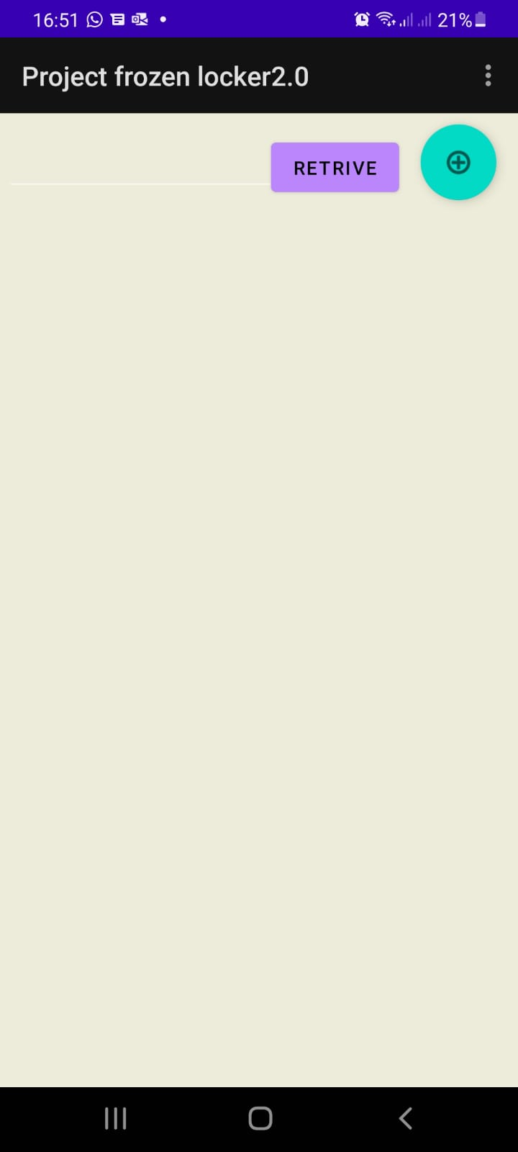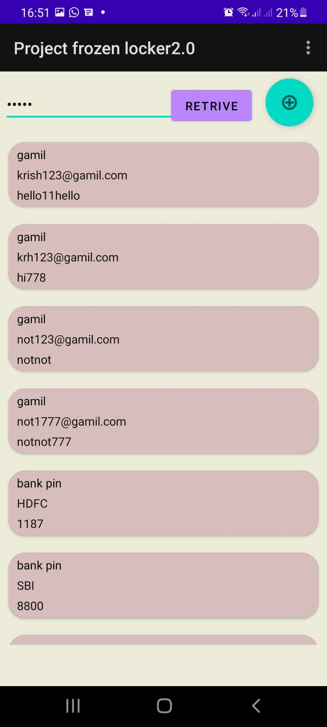

Adding an Account

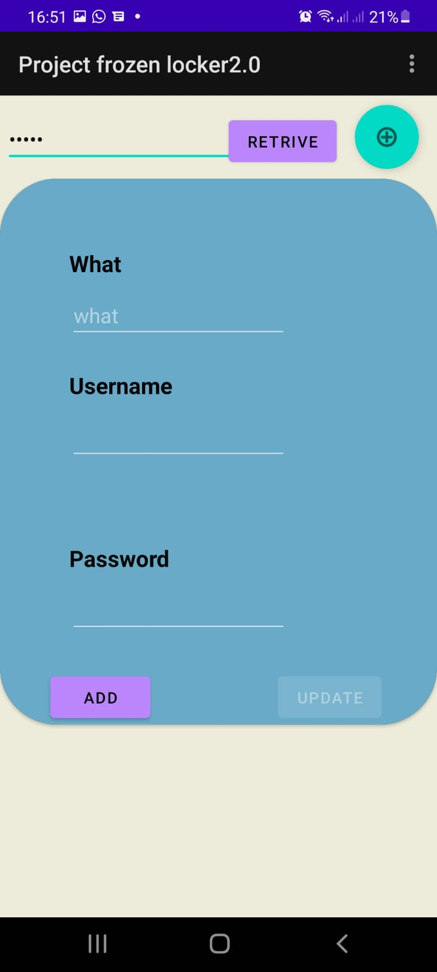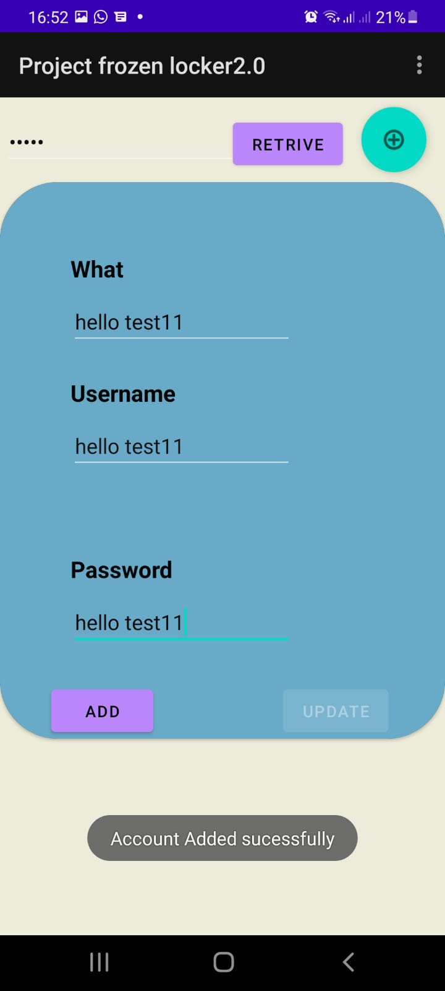

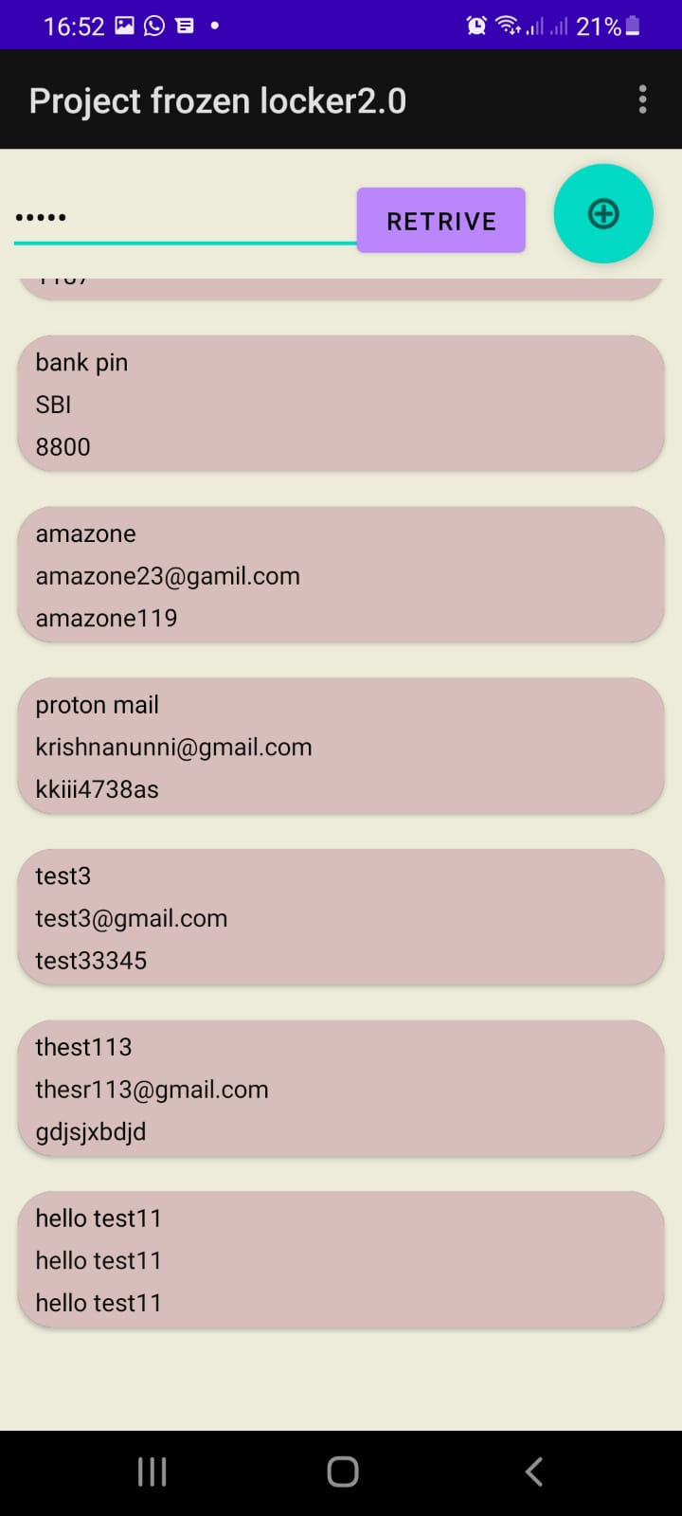

Updating

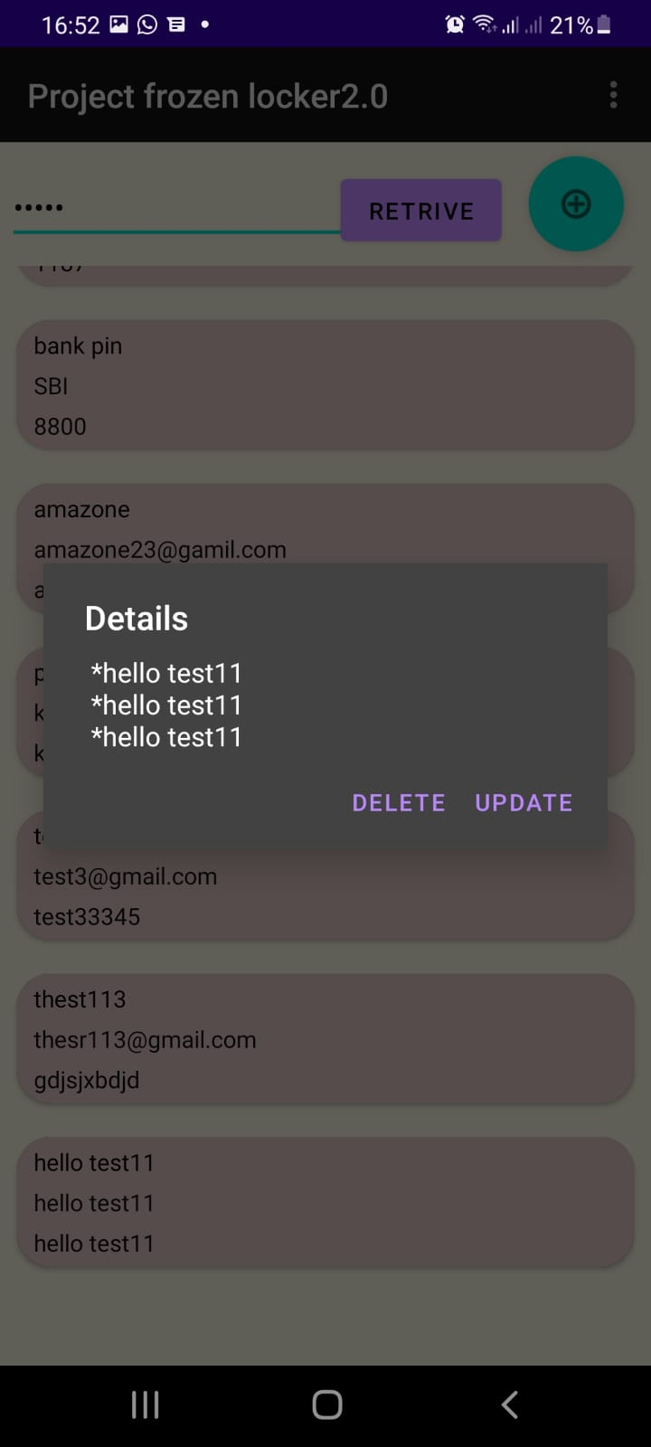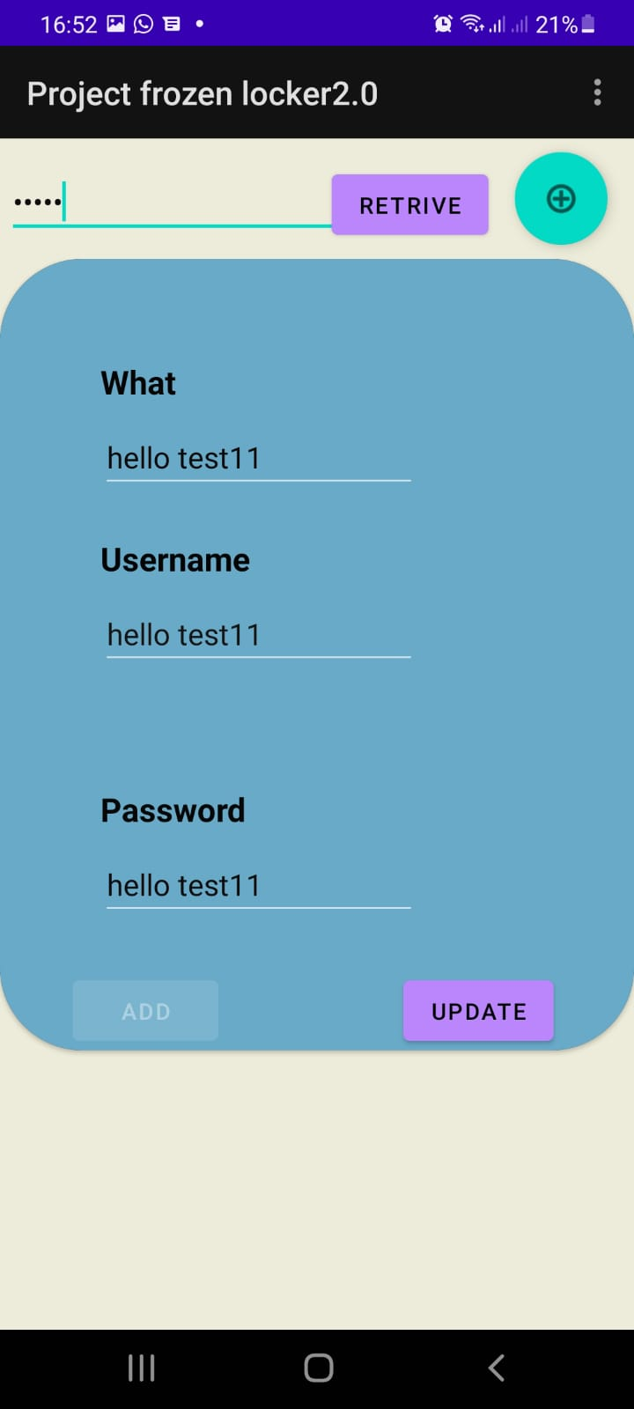

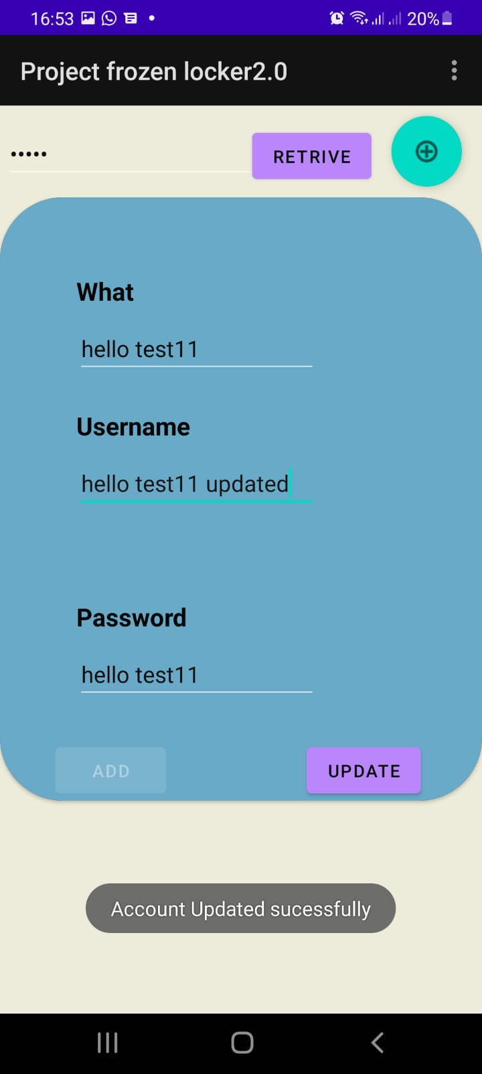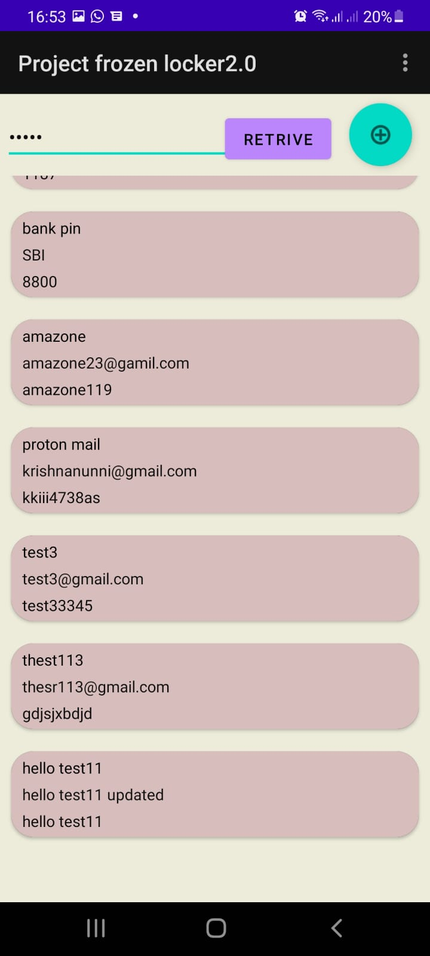

Deleting

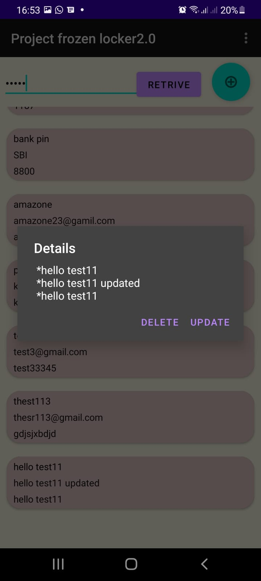

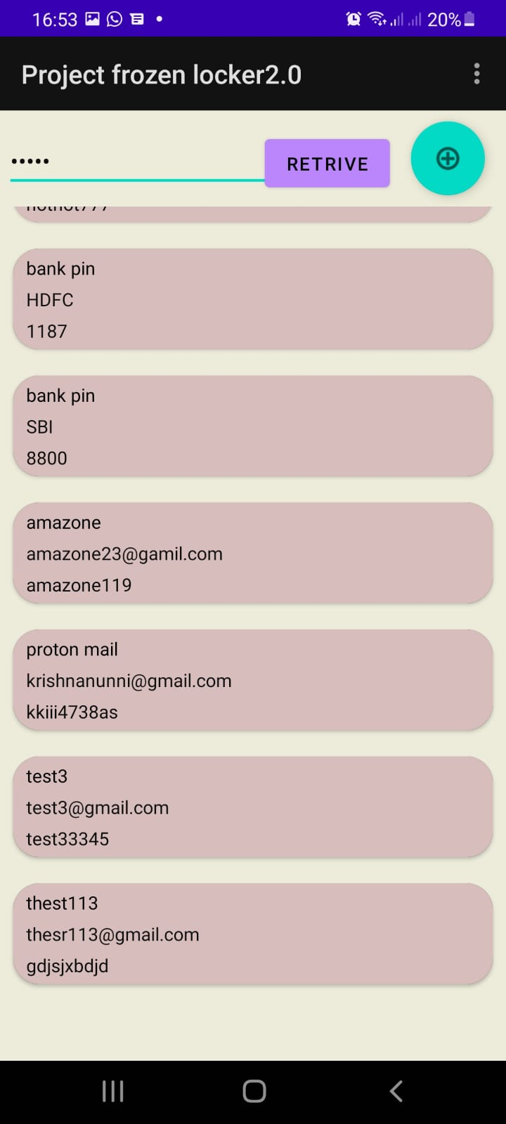

About Activity

